LAB 6

Submitted to:
Sir Mubashir UbaidUllah
Submitted by:
Muhammad Faizan
Registration no:
FA22-BSE-052
Course:
Visual Programming

“Department of Computer Science”
COMSATS University Islamabad,
“Vehari Campus”

Activity 1:

XML code:
<Window x:Class="WPFStyles.Activity1"
xmlns="http://schemas.microsoft.com/winfx/2006/xaml/presentation"
xmlns:x="http://schemas.microsoft.com/winfx/2006/xaml"
Title="Activity 1" Height="500" Width="700" Background="Cyan">
<Window.Resources>
<Style x:Key="Header1" TargetType="TextBlock" >
<Setter Property="FontSize" Value="15" />
<Setter Property="FontWeight" Value="ExtraBold" />
</Style>
</Window.Resources>
<Grid>
<TextBlock Text="Styled Header" Style="{StaticResource Header1}"
HorizontalAlignment="Center" VerticalAlignment="Center"/>
</Grid>
</Window>
Cs code:
using System.Windows;

namespace WPFStyles
{
public partial class Activity1 : Window
{
public Activity1()
{
InitializeComponent();
}
}
}

Output:
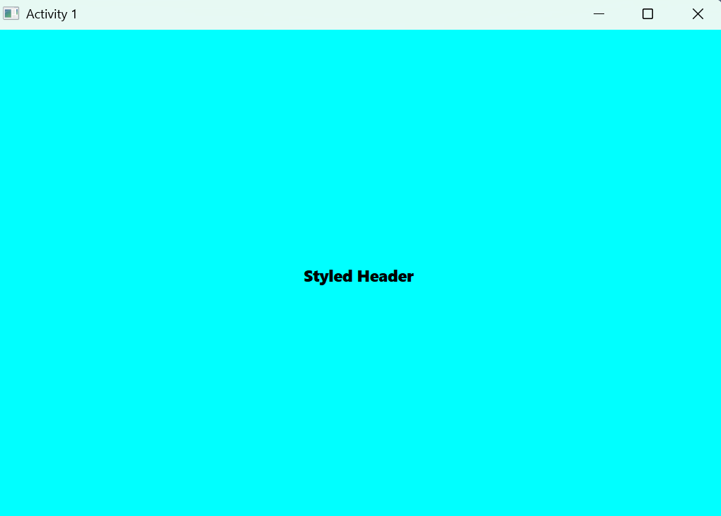

Activity 2:
.xaml code:
<Window x:Class="WPFStyles.Activity2"
xmlns="http://schemas.microsoft.com/winfx/2006/xaml/presentation"
xmlns:x="http://schemas.microsoft.com/winfx/2006/xaml"
Title="Activity 2" Height="300" Width="400">

<Window.Resources>
<!-- Implicit Style applied to all TextBlocks -->
<Style TargetType="TextBlock">
<Setter Property="HorizontalAlignment" Value="Center" />
<Setter Property="FontFamily" Value="Comic Sans MS"/>
<Setter Property="FontSize" Value="14"/>
</Style>
</Window.Resources>

<Grid>
<StackPanel VerticalAlignment="Center">
<TextBlock>My Pictures</TextBlock>
<TextBlock>Check out my new pictures!</TextBlock>
</StackPanel>
</Grid>
</Window>

.cs code:
using System.Windows;

namespace WPFStyles
{
public partial class Activity2 : Window
{
public Activity2()
{
InitializeComponent();
}
}
}
Output:
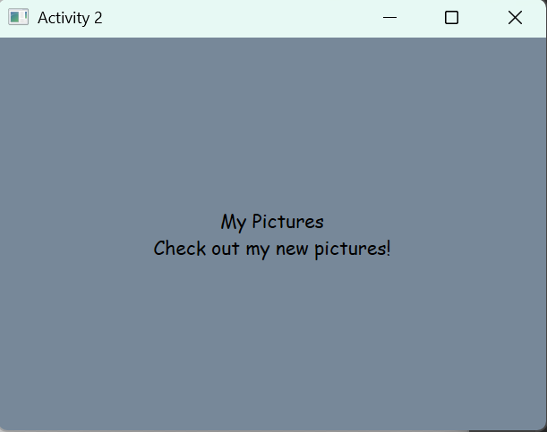

Activity 3:
.xaml code:
<Window x:Class="WPFStyles.Activity3"
xmlns="http://schemas.microsoft.com/winfx/2006/xaml/presentation"
xmlns:x="http://schemas.microsoft.com/winfx/2006/xaml"
Title="Activity 3" Height="300" Width="400">

<Window.Resources>
<!-- Explicit Style (applied only when referenced) -->
<Style x:Key="TitleText" TargetType="TextBlock">
<Setter Property="HorizontalAlignment" Value="Center" />
<Setter Property="FontFamily" Value="Comic Sans MS"/>
<Setter Property="FontSize" Value="14"/>
</Style>
</Window.Resources>

<Grid>
<StackPanel VerticalAlignment="Center">
<TextBlock Style="{StaticResource TitleText}">Styled with Explicit Style</TextBlock>
<TextBlock Name="textblock1">This will be styled programmatically.</TextBlock>
<Button Click="ApplyStyle_Click" Width="200" Height="30" Margin="10">Apply Style Programmatically</Button>
</StackPanel>
</Grid>
</Window>

.cs code:
using System.Windows;
using System.Windows.Controls;

namespace WPFStyles
{
public partial class Activity3 : Window
{
public Activity3()
{
InitializeComponent();
}

private void ApplyStyle_Click(object sender, RoutedEventArgs e)
{
textblock1.Style = (Style)Resources["TitleText"];
}
}
}

Output:
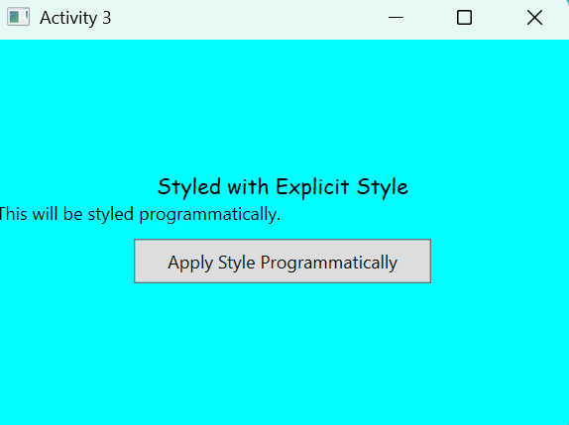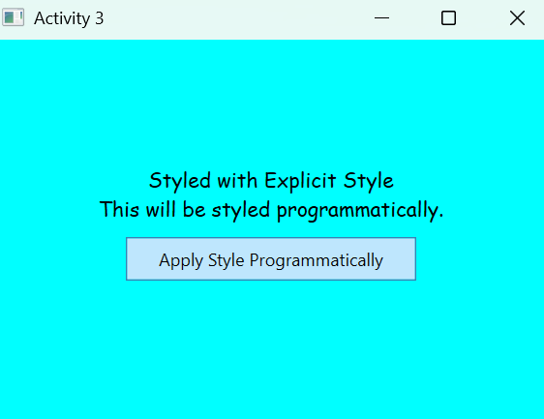

Task 2:
.xaml code:
<Window x:Class="UserRegistration.RegistrationForm"
xmlns="http://schemas.microsoft.com/winfx/2006/xaml/presentation"
xmlns:x="http://schemas.microsoft.com/winfx/2006/xaml"
Title="User Registration" Height="350" Width="400">

<Window.Resources>
<!-- Defining a simple style for Labels -->
<Style TargetType="Label">
<Setter Property="FontSize" Value="14"/>
<Setter Property="Margin" Value="5"/>
</Style>

<!-- Defining a simple style for TextBoxes -->
<Style TargetType="TextBox">
<Setter Property="Width" Value="250"/>
<Setter Property="Margin" Value="5"/>
</Style>

<!-- Defining a simple style for Buttons -->
<Style TargetType="Button">
<Setter Property="Width" Value="100"/>
<Setter Property="Height" Value="30"/>
<Setter Property="Margin" Value="5"/>
</Style>
</Window.Resources>

<Grid>
<StackPanel VerticalAlignment="Center" HorizontalAlignment="Center">
<Label Content="Full Name:"/>
<TextBox Name="txtFullName"/>

<Label Content="Email:"/>
<TextBox Name="txtEmail"/>

<Label Content="Password:"/>
<PasswordBox Name="txtPassword" Width="250" Margin="5"/>

<Label Content="Confirm Password:"/>
<PasswordBox Name="txtConfirmPassword" Width="250" Margin="5"/>

<Button Content="Register" Click="Register_Click"/>
</StackPanel>
</Grid>
</Window>
.cs code:
using System.Windows;

namespace UserRegistration
{
public partial class RegistrationForm : Window
{
public RegistrationForm()
{
InitializeComponent();
}

private void Register_Click(object sender, RoutedEventArgs e)
{
string fullName = txtFullName.Text;
string email = txtEmail.Text;
string password = txtPassword.Password;
string confirmPassword = txtConfirmPassword.Password;

if (password == confirmPassword)
{
MessageBox.Show($"Registration Successful!\nName: {fullName}\nEmail: {email}", "Success");
}
else
{
MessageBox.Show("Passwords do not match!", "Error", MessageBoxButton.OK, MessageBoxImage.Error);
}
}
}
}

Output:
